**SI units derivation**

Kinetic energy is given by ***KE = ½mv²*** , State the derived SI unit for Kinetic energy

Force is given by **F = mass $×$ acceleration ,** State the derived SI unit for Force

Work is given by **W = Force $×$ distance ,** State the derived SI unit for Work

Power is given by **P = $\frac{Force × distance}{time (s)}$** , State the derived SI unit for Power

Given the following velocity-time graph for a car, Estimate:

1. The acceleration of the car at 3 - 4 seconds
2. The displacement covered from 0 to 3 seconds
3. The acceleration at 4 – 7 seconds
4. Using c. calculate the force applied on the car when braking, mass of car = 1300 k*g*

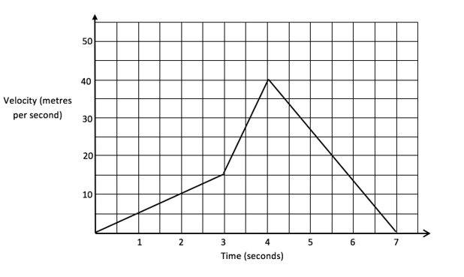

A 2720 k*g* car is moving at a speed of 22 m/s , it takes 3 seconds to come to a stop,

1. Calculate its initial Kinetic energy
2. Find the acceleration
3. Calculate the force exerted to slow down the car to a stop

A fan on a skateboard is pushing 2m² at a 3.3 m $s_{}^{-1}$, knowing the density of the air as 1.23 kg/m³

1. Calculate the volume, then mass of the air being accelerated in front of the fan
2. Calculate the Force exerted by the fan on the air
3. 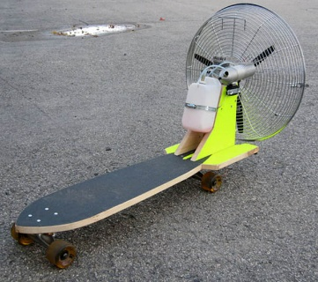After sometime, the skateboard will move at a constant speed, using momentum, explain the reason why it will not accelerate indefinitely

From the figure below, find the weight of the beam.  
Hint: the beam is exerting a weight at the midpoint, consider it as a weight in the middle

